Brendan Brence

Introduction to TableTopBattleMap:
This program is a representation of a table top battle map. The rules and flow of the game is inspired by the rules of d20 roleplaying games such and Dungeons and Dragons. The initial plan was to imitate the combat rules of D&D 3.5th edition as close as possible while remaining within a reasonable size for the project. An additional goal was to create the project with as few dependencies as possible. In order to keep the size down, many official features were cut and rules changed to still make it semi interesting to play. Notable changes from the source material include, but are not limited to, no magic, no special attacks such as tripping or disarming, no dual wielding, limited selection of feats, no class system inbuilt, and no interface to level up build or improve characters. Other features that were not added were purposefully left out to keep the game portion mildly interesting, such as limiting the characters to one attack a round, no attacks of opportunity and a smaller movement speed per round. This was mainly for design considerations and could be easily expanded to at a later date.
The dependencies for the project are Simple Direct Media layer 2.0, hereby referred to as SDL or SDL2, and a compiled dependency called kiss_sdl, which is code written in C for menu operations. Outside of the code there is a folder structure whose root should be at the same level as the .exe file, this contains necessary resources such as textures, scenarios, maps, characters, feats and items. These are loaded in via load functions in the project itself.

How to install:
A user should be able to simply take the supplied zip file, extract it to any desired directory and run it there. Some precautions should be taken if/when editing text files that are used by the program.
Firstly, users should only use notepad++ and other file editors that do not add characters to the file in question. It is a known issue with microsoft file editors such as wordpad and notepad that they add and save hidden characters to files upon opening, this causes unpredictable behavior and crashes when running the .exe, as the loader does not know how to handle the hidden characters. Only notepad++ has been tested successfully.
Secondly users should only use .png files as textures, as this is the best supported format for SDL to use.
Thirdly, keeping the folders clean of other files is important, the loading algorithms often loads all files and textures in certain folders, and will not always know how to process garbage files, particularly in the case of the texture folder.
Other than these considerations installation should be straightforward and easy, as the dependencies were kept to a minimum.

Brendan Brence

TableTop Battlemap Manual

Table of Contents:
General Usage:
Main Menu Operations:
Scenario Menu Operations:
Encounter Operations:
The Display
Entities
Items
Feats
The Combat Round:
Initiative
Attacks and defense
Melee
Ranged
Movement
Player Controls
End Condition
Feats
Items
Maintaining File Fidelity and creating new files
Structure of Scenario file
Structure of Character file
Structure of Feat File
Structure of feats
Structure of item file
Structure of Map File
Structure of Texture Folder
Editing files
General Usage:
Installation guide:
Move the zip folder to any new, clean folder, and unzip there. The unzip program should place all files in the correct location. The user then can double click the .exe file to run the program. Nothing else is needed for setup.

Main Menu Operations:
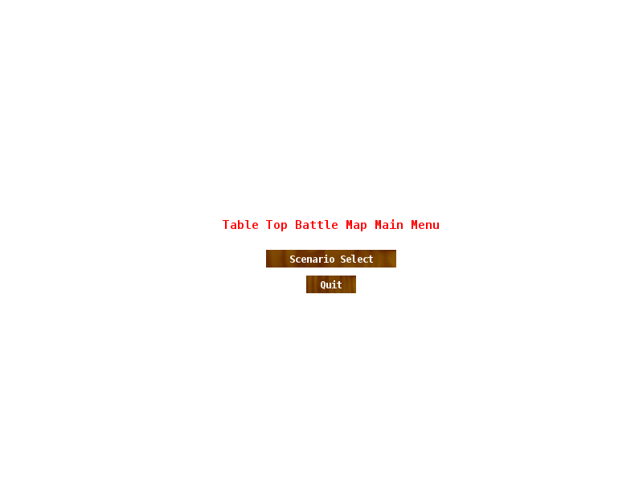
The main menu displays the name of the game and two options (if this does not display make sure the texture folder is in the correct place):
Scenario Select:
Selecting this brings the user to a different menu (scenario menu), in order to select what scenario they would like to run.
Quit:
This quits the running program.

Scenario Menu Operation:
The scenario menu is simply a file browser for the user to interact with to load what scenario they wish to play. The filenames are displayed on the screen in the large center textbox with the vertical scrollbars to the right side. There is an entry at the bottom of the textbox. There are two buttons on the bottom of the entry 'Ok' and 'cancel'
Textbox: Clicking any filenames will select the file in the menu, it will be loaded into the text entry below the textbox. The scrollbars on the right side will pan through the files if there are too many to display on the textbox at once.
Entry: The entry cannot be interacted with, it is to display what filename is selected.
Ok Button: attempts to load the selected file
Cancel button: returns user to main menu.
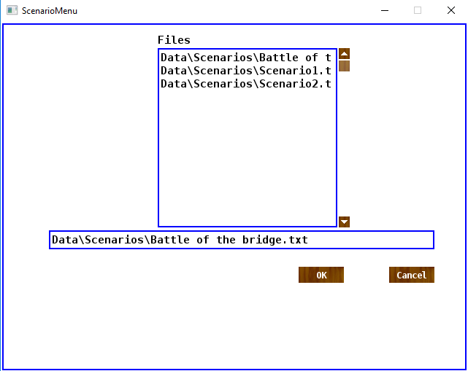
Selecting desired scenario:
Clicking on the filename of what scenario is desired will select it, in the text entry field the selected filename will show. There selected filename will also highlight in the textbox. Clicking the 'OK' button will load the scenario and launch the encounter.

Encounter Operation:
Elements of the Encounter screen:
TileMap:
The TileMap is located in the top right hand side of the screen during the encounter. The TileMap is where the actual encounter is rendered, there are representations for entities and items that are scattered on the map, as well as visual representations based on each tiletype.
1. An entity, given a texture by their character sheet, or given a placeholder texture (MaceMan) if none found. A color is rendered over their tile to display the side of the entity. Blue is player side / controlled, and red is the side of the opponent (AI controlled). The entities face in the direction of their most recent action.
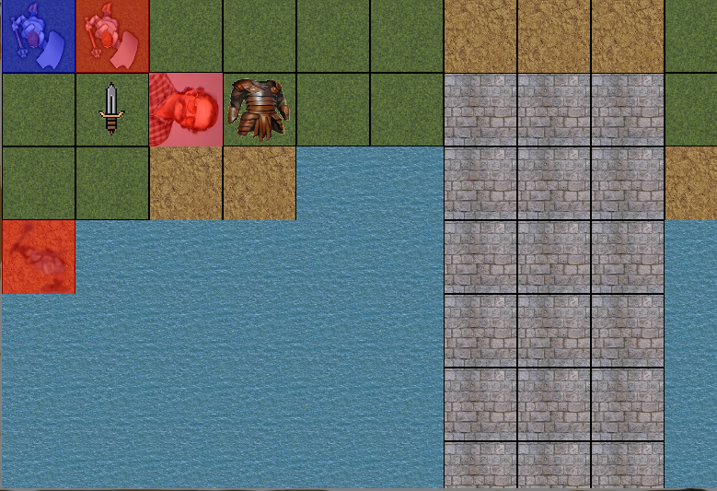
2. Daggers on the tilemap represent weapons on the ground when they do not have a matching texture, leather armor pieces represent armor on the ground. Only one of these textures will be rendered per tile, whichever item was dropped last will be rendered.
3. Tiletypes are represented by the given tile's texture, some tiles are passable (stone, dirt, grass), water blocks passable but does not block line of sight, some tiles block both line of sight and the ability to pass (the black out tiles). These are clipped from a singular texture at encounter start.
Display panel:
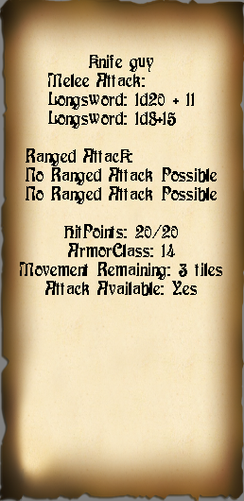
The display panel is the top left panel and it represents information about the currently active entity. It displays the name at the top, followed by the attacks available to the entity, melee and ranged with their associated die rolls. It also displays the current and maximum hitpoints of the entity, their armorclass, if they have an attack left and how much movement they have remaining.
Log panel: The log panel is the bottom panel on the encounter screen. It displays interactions (attacks and damage) in the log, with the most recent at the bottom. It has an upbutton and down button. The upbutton will display older entries and down button more recent entries.
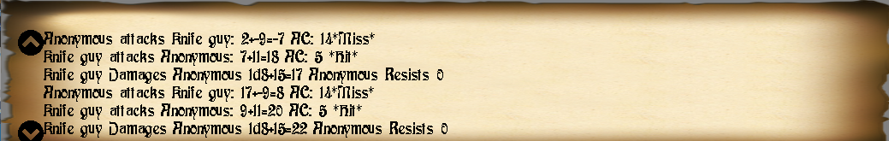
Entities:
Entities represent characters that are loaded from character sheets maintained separately from the scenario pages. This allows for entities to take place in multiple scenarios while maintaining a single character sheet. The character sheet outlines what statistics are stored for the entity.
Name: Each entity has a string name, this will be used to identify the entity alongside its texture in the point of view of the user. So choosing unique names for the player side units is important! (Users will not be able to see enemy unit names)
Hitpoints: Entities are given a set amount of 'hitpoints', these are lost when successfully attacked, and when they reach 0 the entity dies and is removed from the game.
ArmorClass: Armor class is the measure of how well an entity can defend itself from attacks, the base armor of an entity is 10. This is primarily modified by the dexterity and worn equipment (armor) of an entity. Some feats modify the armor class of entities.
BaseAttackBonus: The base attack bonus is a given number that adds to every attackroll the entity makes.
Ability scores: The ability scores of an entity contribute to its attack rolls and damage, for this program only Strength and Dexterity are currently used. Strength adds to the attack and damage of a roll made with non-light weapons and throwing weapons (and light weapons when strength is higher). Dexterity bonuses are added to light weapons and ranged weapons, and is added to the armor class of an entity as well. A user does not need to switch between using dexterity and strength for attack rolls, the better of the two is automatically calculated and used.
The ability scores assume that a score of 10 is 'average' and any number less than it will incur a penalty and any number greater than will give a bonus. The bonus increases every two levels. So 12 & 13 give a +1 bonus, while a 14 & 15 give a +2 bonus and so on. This is true in the opposite direction, where 9 & 8 are -1 and 6&7 are -2 and so on.
Feats: Feats are special abilities that are either always active, such as proficiency in a weapon or armor, or can be toggled on and off. Some feats have a 'range' that can be slid through, usually giving a bonus to one area and a negative to another. For example: Power attack is a range ability that can be cycled through between 0 and 5, for every step the entity has another -1 to attack rolls, but +1 to damage rolls with all weapons, and an additional +1 to damage rolls for two handed weapons. This adds so power attack gives a total of -1 to hit for each step and a total of +2 to damage for each step when wielding a two handed weapon.
Items: Items that are equipped or carried in the entity's backpack are listed on the entity and the location they are in. The entity has many different slots available, but currently only items designed and load routines exist for the body slot(armor), and the hand slots broken up into mainhand and offhand (weapons). The entity's backpack is of unlimited size and can hold a (seemingly) limitless amount of items.
Texture: This determines what texture the program will attempt to load into the entity, it will be its visual representation on the battlefield. This texture has its own qualities and is passed to the renderer approximately 60 times a second.
Actions: Every turn the entity is given 3 move actions (1 tile is equivalent to 1 movement, diagonals are 1.5) and 1 attack action. Picking up items, dropping items, changing feat options and managing the inventory are all considered free actions, and incur no cost.
Initiative: Initiative is determined at the beginning of an encounter, it is rolled on a d20 and the entity's dexterity bonus is added to it. The higher an initiative, the sooner a unit can react.
The Encounter:
At the beginning of an encounter every entity rolls what is called 'initiative', this is a measure of how quickly the entity initially acted and determines its order of play, with higher values going first. A full combat round is encompassed by every entity acting in order. Each entity has 3 move actions and a single attack they can make a round. Player controlled Entities can also interact with their environment by picking up items, rearranging their inventory and changing what weapons are equipped and toggling their feats. However AI players will not attempt to pick up items or change their feats beyond the default values given to them. The Camera focuses on whatever entity whose turn it is or the target system if it is active.
Entities may move up to 3 tiles on their turn (diagonal movement costs 1.5 tiles) and make an attack. In order to make a melee attack an entity has to be next to its target. To make a ranged attack the entity must be able to see its target. The general formula for resolving attacks are:
1d20 + STR/DEX + Base attack bonus, This total is compared against the target's armor class, or 'AC' if the first roll meets or exceeds the targets AC it is a hit. If the target rolled over or the same as the critical hit threshold for the weapon being used, the entity makes a second roll, a “critical threat roll” that is the same as the first roll, if this hits the target's AC again the attack is then a critical hit, and deals a multiple of damage equal to the item's critical multiplier.
For ranged attacks, whether or not the target is obstructed and how far the entity and its target is determines additional values. Other units standing in the way of an attack cause the ranged attack to be obstructed, this is a -4 penalty to the attack roll. If the unit is outside of the weapon's 'range increment' then it has a penalty of -2 to hit for every range increment beyond the first.
Controls:
For movement the user can press the arrow keys for the corresponding cardinal directions, or use the keys to move in the corresponding direction:
q w e
a d
z x c
To make a melee attack the key 1 toggles from movemode to attack mode, and uses the same keys as the movemode to attack the surrounding tiles. There is no interface display to signify this switch, however accidentally attacking an empty tile or attempting to walk into an opponent or wall does not take any actions, so the risk of wasting unintended moves is only slight.
For the user to make a ranged attack they toggle their ranged attack button '2', where a target appears on the screen, the target is controlled in the same manner as movemode, and must be placed over the target that the user would like to attack. Pressing the enter button then executes the attack.
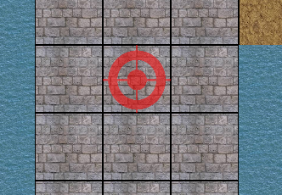
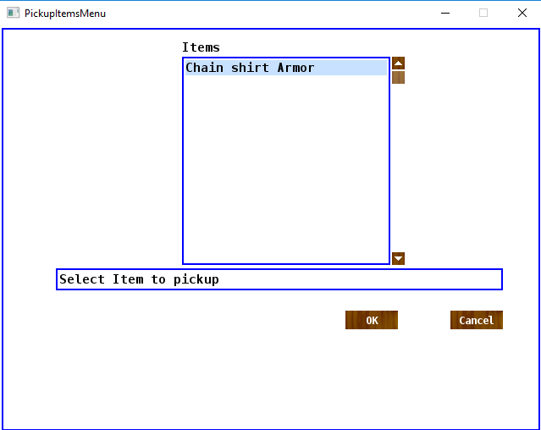
Pickup Menu: Pressing the '3' button brings up the 'pickup menu' which allows the entity to interact with their environment by picking up items from the tile on which they are standing. The items are listed by name in the text box from the top down. Selecting them is straightforward, clicking on it will show the name in the entry below the textbox, selecting pickup will have the entity pick up the item and place it into their backpack, or their hand depending on if it is a weapon or not.
Inventory Menu: Pressing 4 brings up the inventory menu. This allows the entity to interact with objects on their person and in their backpack. The items display from top down prefixed by where they are on the entity. There are several options available to the player.
Swap: Swap swaps the items in mainhand and offhand, useful if player wants to switch which weapon they are attacking with since mainhand is prioritized as weapon of choice.
Two hand: Attempts to grab the weapon in the mainhand with both hands. Only useful with weapons that are not light.
Drop item: Drops the weapon in the tile the entity is currently at.
(Un)Equip: Contextual command depending of weapon is on the person or in the backpack. Will take an item from the backpack and attempt to put it on the entity or take an item off the entity and place it in their backpack.
Cancel: Exits the menu and returns back to the game. Changes do not need to be saved and are made the second the command is called
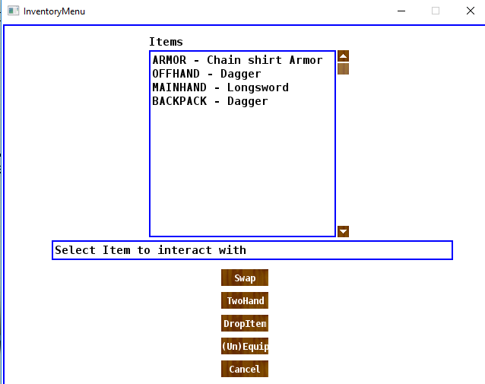
Feat Menu: Pressing 5 brings up the feat menu, this is how entities interact with their feats. Feats that are intractable are listed from top down same as the inventory.
Feats that have a range setting: Plus and minus buttons are to change the range on feats that have a range. Pressing plus will advance the feat one step, and the minus will move it towards zero. Generally speaking, range feats should not have a possible range less than zero.
Toggle Button: The toggle button turns the feat on and off, assuming it is a feat that can be toggled, such as the feat, power attack. (toggles its active status)
Description button: currently not implemented and exists as a placeholder for future use.
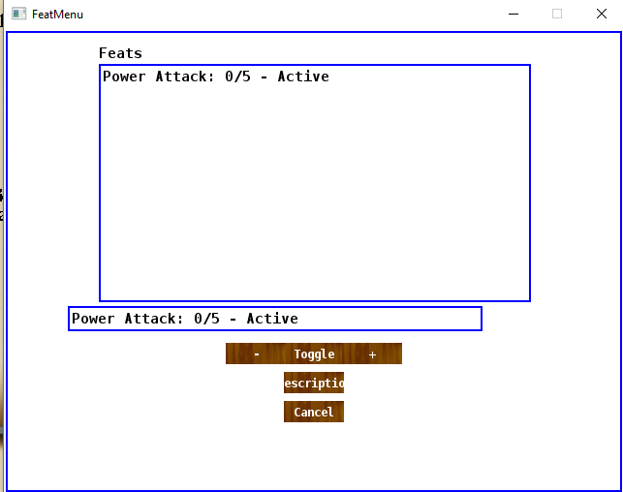
Cancel Button: The cancel button closes the menu and returns to the encounter, allowing it to progress.

Encounter over
The encounter ends when all units on the player's side die or when all units not on the player's side are dead. A popup message will display telling the winner of the round, or if the user quits the encounter by pressing the x on the encounter window.

Feats
Feats are “features” of an entity and can only be found belonging to entities. They are abstracted abilities and attributes that a character has that makes them good at different things. In the scope of this program feats are all about combat. They are sorted into two major categories. Proficiency feats and normal feats.
Normal feats are often simple numerical advantages such as a +1 to hit, or +2 to damage with a certain weapon type or group.
Proficiency feats are to show the character / entity is proficient using a specific weapon or armor. If the entity is not proficient in using a weapon then they receive a -4 penalty with every attack using it. The loading functions can only handle certain types of bonuses and penalties assigned to it. These will be covered in the maintaining file fidelity portion of the manual.
Items
Items are objects that exist within the game world to be equipped and used by characters. They are split into two major categories: Armor and Weapons. Weapons fit into the Mainhand or Offhand body slots on entities, Armor fits into the body slot on an entity. All objects have shared statistics such as weight & body slot.
Weapons are used to augment an entities attacks and make ranged attacks. Each weapon has damage dice associated with it, critical strike information, range increment (melee weapons have zero range), weapon type(s) and damage types.
Every weapon should have at least 1 weapontype, the weapontypes are listed here and may have overlapping weapons:
POLEARM – Weapons like Glaives, halberds, spears, etc
AXE – hand axes, two handed axes, baradiche, etc
SWORD – short swords, long swords, greatswords, etc
CLOSE – knives, saps, fists, punch daggers, etc
HAMMER – throwing hammers, great hammers, picks
MACE – maces, flails, mauls, etc
BOW – shortbows and longbows
CROSSBOW - crossbows
THROWN – any weapon with the throwing property, daggers, javelins, spears
NATURAL – fists, claws, etc
UNARMED – fists, kicks
// These are more general categories, made for weapon proficiency types
SIMPLE – weapons that require 'less' skill to use than martial weapons
MARTIAL – things more like longswords and glaives, halberds, longbows
IMPROVISED – non weapons
LIGHT – often overlap with the close category, these don't get advantage when being used in two hands, but can use the entity's dexterity modifier for damage
RANGED – dedicated ranged weapons, bows, longbows, crossbows
MELEE – anything not a dedicated ranged weapon
Armor is to protect an entity by adding its armor class and add to its damage reduction. It has a statistic called 'max dexterity' which prevents the entity from taking advantage of dexterity scores above a certain number. It also has an armor type attached to it. The idea of armor restricting mobility was dropped from this iteration for gameplay reasons – without double moves + charge attacks implemented, entities in light armor with ranged weapons could avoid anyone in heavy armor indefinitely.
Light Armor – things like leather armor, padded shirts, heavy gambesons, don't restrict dex or mobility nearly as much as heavier armor types. Made for skirmishers or archers more than front line soldiers.
Medium Armor – more like chain shirts, breastplates, starting to restrict movement, but offers more protection than light armor.
Heavy Armor – full chain suits, splint mail, lamellar armor, Full Plate. Restricts movement and dexterity greatly but offers incredible protection.

Maintaining Data files
The data that can be changed by the user is maintained and stored in a folder structure starting on the same level as the .exe. The main folder is called 'Data'. There are several subfolders each handling different categories of data that is loaded by the program. The folders that are necessary to be present are 'Characters', 'Feats', 'Fonts', 'Items', 'Maps', 'Scenarios', 'Textures'.
Characters: The individual files in the characters folder is only accessed when Scenario files reference characters, these files are accessed by filename. Character files hold information inherent to the character. Every piece of information should be preceded by what information it is, and each line should usually only hold a single piece of information. For example at the beginning at the example file there is a line preceded by 'Name:' and the name of the character after that. Each section of information has its own small form that needs to be followed for the file to be accepted.
Ability Scores: Abilties are representations of 'inherent' character attributes, how strong someone is, how good they are at taking a hit, how agile they are, etc. In the file are first declared as their type, either 'Strength, Dexterity, Constitution, Intelligence, Wisdom, Charisma, followed by a colon, and then the number that is assigned to that stat.
End Ability Scores: ends the selection.
Properties: starts reading properties, which consist of MaxHitPoints: and BaseAttackBonus: and are formatted the same way ability scores are.
Equipped items start reading items and placing them into body slots that are the line precedent. Example to place a weapon into the mainhand the line should start with 'MainHand:' followed by an item. The items are identified by string for the name of the item so they must match identically. If a body slot is empty it should not even be mentioned, it is assumed that slots are emptied until they are loaded.
End Equipped: ends body slot equipment.
Backpack items are loaded between Backpack: and End Backpack:, these are loaded like equipment so they must match an item letter for letter. They are loaded directly into the entity's backpack and will be there at game start.
Feats are loaded the same way as items, where they are between Feats: and End Feats: and are loaded my name, and must match the featname identically.
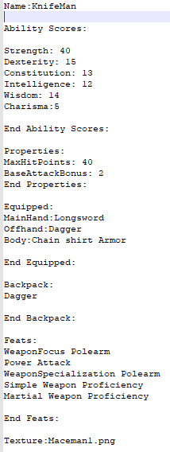
The texture at the end is loaded by filename, and must match a texture filename located in the texture folder. Textures should be close to 80 pixels wide by 80 pixels long, it will be skewed to fit this size regardless, but larger textures may fail and the texture will be unrecognizable or squished in a way that it does not fit in the tile, leaving an empty tile.

Feat files:
Feat files are the most complex files that exist for The TableTop Battle Simulator. There are several types of feats and feat options that exist. Every feat starts with a <Feat> tag and ends with an </Feat> tag, similar to xml syntax. A common feat type is a feat is called an “each” feat, which is predicated on what it is a feat for. This will communicate to the loader that it needs to create a feat object for every existing type. Example:
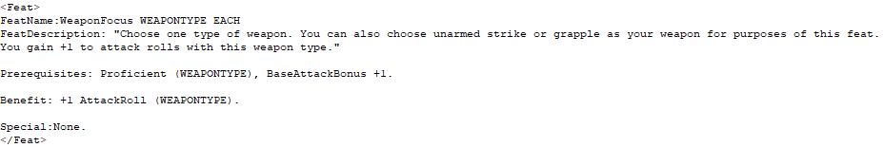
the names of the type (generally weapontype) and each statement are replaced for each feat for what type they are applying to. In example above a feat will be generated for Every weapontype coded into the program, the feat names will be as such – WeaponFocus Swords, WeaponFocus Axes, and so on and so forth for every weapon type. In every other category WEAPONTYPE is replaced with whatever weapontype a feat is being created for.
Normal feats: Normal feats have other names and do not have special naming rules.
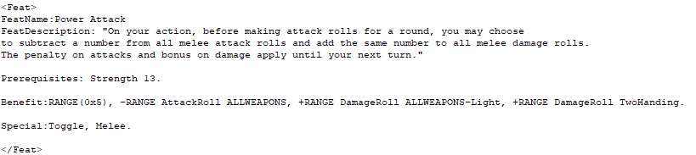
Here is an example of a 'normal' feat, powerattack.
Feat descriptions are placed in quotes after 'FeatDescription:' The display for feat description is not implemented so it is only important to remember what the feat is supposed to do, or for flavor.
Prerequisites are not implemented as a leveling system is not implemented, so they are not required to be included.
Benefit: benefits for each feats are generally flat modifiers to attack rolls, dodge bonuses, or AC bonuses. There are several keywords that the loader knows how to read. One of them is RANGE. This is for declaring feats that have a range the player can move up and down on, the range must be declared at the beginning of the benefit line, within parentheses and an x between the two values. Each piece of information is separated by a comma, with a period at the end of the line. The program parses each phrase sequentially. Each instance of RANGE is recorded in the feat that there is a range for these feats. Every phrase must work off of RANGE instead of hard numbers. A subtraction or plus before the RANGE keyword indicates which direction the range slides as the feat value is increased.
Another keyword shown in this example is ALLWEAPONS, which will default to telling the feat that every weapon type is affected. A subtraction sign after the ALLWEAPONS keyword is for an except clause, allowing feat creators to exclude certain Weapontypes, shown in this example as '-Light'. So the phrase '+RANGE DamageRoll ALLWEAPONS-Light' tells the loader that this phrase is using a range, and that for every step of the feat it adds positive one damage for every weapontype, except for weapons containing the light weapontype. In addition to weapontypes, circumstances can also be given, as in this example uses TwoHanding, which is not a weapontype, but a circumstancetype.
The 'Special:' clause is not required, but is used to pass specific circumstances necessary where the feat will function. In the above example two special circumstances are passed, Toggle and Melee, this communicates that the feat can be toggled on and off by the user, and that it only affects melee weapons.

Item Files
Item files are files the program loads into memory as objects for the entities to interact with and use ingame. Currently the user cannot add their own individual files to be loaded, and must instead add to existing weapon and armor files. There is a specific format for each item that must be followed, or unforeseen and possibly catastrophic circumstances will arise during the loading process or during the course of gameplay.
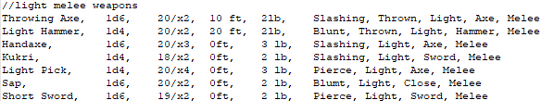
For weapons:
These are examples of weapons in the martial weapons file. Each weapon rests on one line and one line only. The order of information is rigid and must be in the order shown in this example, each phrase of information is separated by a single comma. The first phrase is always the name as it will appear in game and be recognized by the program.
The second is the damage dice that the weapon uses, the first number being the number of dice rolled, the second being the size of the dice rolled.
The third phrase is the critical information, with the first number representing the number that must be rolled on the to-hit die in order to threaten a critical hit, with the second dice being the damage multiplier on a successful critical hit.
The fourth phrase is the range increment, non ranged and non thrown weapons should have a range increment of 0ft.
The fifth is the weight of the object.
The last set of information is damage types and weapon types that the weapon is / possesses, with each type separated by commas. The weapon should be either melee, thrown or ranged, or it may cause issues within the program. The filename that the weapon is in also influences what types the weapon is part of. Every weapon in the simple weapon filelist has the simple weapon type added to them and same with the martial weapon file.
For armor pieces they are shown here in their format.
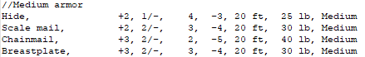
As the same as the weapon information, all info for a piece must rest on the same line, in the order shown here. The first phrase, such as in weapons, will be the name displayed and used internally by the program.
The second phrase is the amount that this armor adds to the entity's armor class, making it harder to hit. This number will always be positive.
The third phrase is the damage resistance amount, adding to the entity's ability to resist damage, this number will also be positive.
The fourth is the maximum dexterity allowed. This is the hard cap on the entity's ability to use higher dexterity scores. The number is the dexterity modifier, so a 4 max dex cap means the entity cannot benefit from having dexterity scores above 19.
The fifth is the armor check penalty, this would penalize certain skills, but no skill system exists, so this is not used.
The sixth is also not used, as it is the max speed imposed by the armor, which is unimplemented for gameplay reasons.
The seventh is weight in pounds.
The eighth is the rating of armor, chosen from light, medium, and heavy.

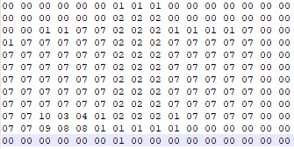
Map Files
map files are files of integers currently limited to 16x12 maps read by the load function to create tiles that the encounter is played on. The map file is a set of pairs of integers set in the format shown, each pair of integers represents a tiletype between 00 and 12.

Scenario files:
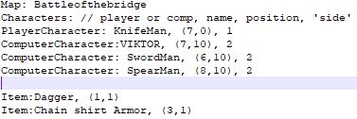
Scenario files are in the Scenario folder and are the main files that load from specified map and character files. Scenario files include lists of characters with what location and team they are on, and a list of items with where they exist on the encounter map.
The map file searches by name and must match a map file name in the map folder.
Each character must have a preceding indicator if they are Player Controlled or Computer controlled, so the program knows how to set up the AI. The Name must match a file name in the character folder (except the .txt is left out). The location must be within a set of parentheses, and name, location, side must be set apart.
In each scenario there must be at least one entity on the side1, this is called the player's side, and if no entity is on side1 then the encounter will end immediately in favor of the AI.

Texture folder:
The textures found in the texture folder are suggested to be in .png format, as they work best with SDL. It is suggested to not remove or rename any of the textures that came with the installation, as these may be relied upon by the program routines separate from character models.

General File Integrity:
In order to maintain file integrity the formats shown and explained in the previous sections should be followed as closely as possible. If these formats are not followed it will cause unexpected behavior in the program.
If the files are opened with microsoft products they have a high chance of being edited by these products and causing unexpected behaviors and even exceptions and crashes. It is highly reccomended when editing or adding files that the user uses Notepad++, found at https://notepad-plus-plus.org/, this will protect against the addition of hidden characters as microsoft products are known to do.
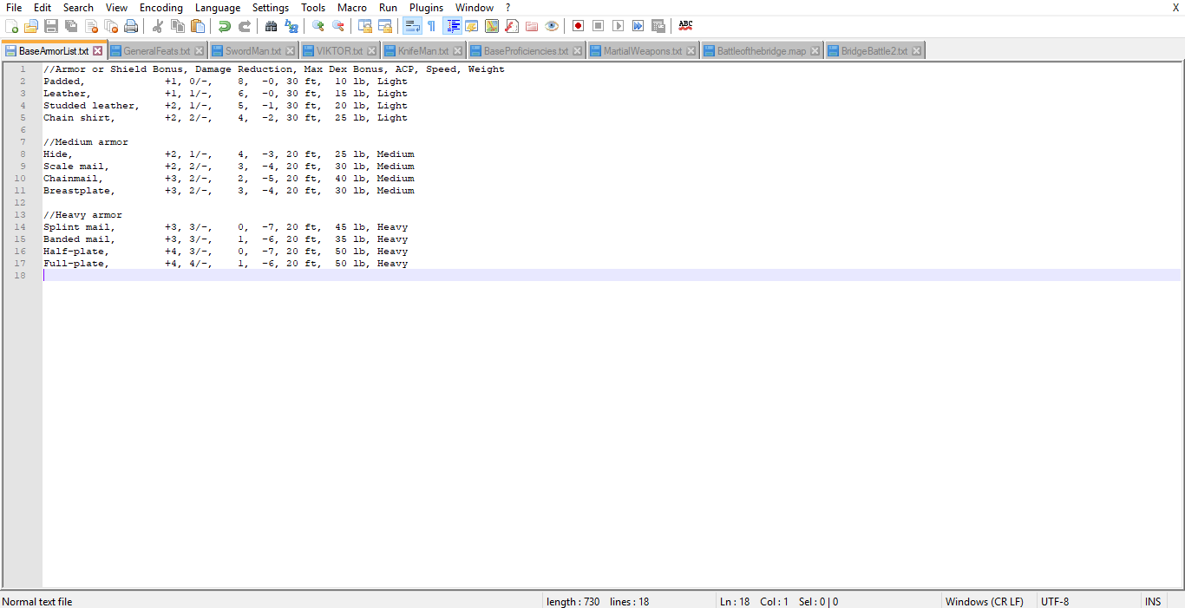

Brendan Brence
Overview of TableTopBattleSimulator:
1. As stated in the manual and introduction the game is heavily inspired by Dungeons and Dragons combat rules, and similar D20 combat systems. The objective in these "encounters" is to pit one side's pieces, the players, against a set of enemy pieces, and usually fight until only one side remains standing. There are many rules and statistical considerations when heading into engagements. In my version it is very simplified, as there is no semblance of a magic system and it is only combats between human opponents wielding nonmagical weapons and armor.
2. The feats, items, characters, maps, scenarios and textures are all loaded from text files that are readable and modifiable by the user, the loading is handled by the program and each file's required format is in the manual. The loading being handled by the program was to lower the number of dependencies that the program requies, instead of using a third party json or xml loader.
The loading processes all work off of finding keywords in the text files and interpreting information according to its relative position to the keywords. This is similar to xml and json format. Each file format is shown in the manual, but is often based around finding a keyword and extracting the information to the next deliminator character (most often a comma)
3. Encounters are objects within the program that store the information for a given combat or given scenario, in the encounter is also the functions to handle the round to round information, updating and rendering of all menu's and displays as well as the entity's and tilemap.
The tilemap is simply a vector of vectors that holds a tile in each spot. Tile's information on the encounter map.
Tiles are small objects mostly with a tile type (int), a few bools, and pointers to objects that exist on the tile. The tiletype of the tile determines whether or not it is passable when no entity is there. Certain tiles are not passable, but can be seen and shot over fine.
4. Each entity is an object and stores information regarding the entity, what it is equiped and how it reacts to user input.
To track what the entity is trying to do, each entity has a "controlmode" enum value stored. There are several values that exist for each mode the Entity is in. These help the program decide what to do when the user gives key input.
The default value is MoveMode, when the user presses buttons in this mode / context, the move function is called.
The second most common value is melee attack mode, it calls the attack function, which works off of move directions passed by the user to find and execute attacks against targets
If the unit is ranged attack mode the encounter shifts control to its inbuilt targeting system, which will then be controlled by the user similarly to an entity.
The pickupmode, Inventorymode, FeatOptionMode, will all call the menu functions by the same name.
AIMode cannot be set by the user but is set by the encounter at loadtime, this calls the AIPlayer to take the turn for the entity.
The Players are controlled by the number keys to set the mode. The arrow keys and the keys q, w, e, a, s, d, z, x, c set an internal enum value called 'movedirection', if movedirection is set to non-stationary value while in MoveMode or Melee attack mode it will be evaluated as a command in that context. There is currently no distinction between the arrow keys and the letter keys, yet no way to move diagonally with the arrow keys exists. Furthermore diagonal movement is intentionally limited, if the entity could not pass through the tile the same way as its horizontal movement or its vertical movement then the entity can not move diagonally.
5. Items in the scenario are each objects in the program. Each has its statistics stored, they are read from lines in the object files and created at encounter load, and kept track of by their name (string). They are primarily interacted with by pointers. The items augment attacks and the defence of entities.
6. Attacks are objects themselves, melee attacks and ranged attacks both inherit from a singular virtual class AttackClass, so they are very similar in structure, the only difference is they calculate their bonuses individually, each attackobject contains its own functions for calculating everything that happens during an attack and only needs the source of the attack, the encounter, and the target of the attack. It passes a readable result to the encounter, which is passed into the log to display to the user.
8. Feats are also classes themselves, they are mainly just classes designed to store information, not much manipulation of data is done after loadtime. They have many different categories of bonuses, mostly represented by different maps and ints to represent bonuses under circumstances, weapontypes, armortypes, etc. These are accessed later by functions in different classes that pass the specific circumstances of the situation and compare it against each feat owned by the player.
7. There is only one AI 'player' per encounter, they control all of the AI controlled units, keep track of their paths and contain algorithms for controlling the units. The AI player has two maps for storing the AI's target, and storing the AI's path to targets. If the AI's target hasn't moved and the path is not blocked, it continues what it was doing the previous round, otherwise it checks if there are closer targets pathwise, and updates the target and path accordingly. The paths are a series of tiles that the AI controlled entity will attempt to walk tile by tile. There are algorithms to determine the ai's set of actions every round.
Every round the AI queries its currently controlled entity and sees if it is a unit that is capable of making ranged attacks, (without throwing away their last weapon) if they can it will attempt to make a ranged attack if there is an unblocked entity in sight, or move closer to the nearest enemy entity in order to make a ranged attack. If it cannot make a ranged attack it will default to melee attacks. The AI always attempts to move to the targeted entity when melee attacking, and will always target the closest entity possible in order to attack. The AI is limited in the way that it does very little action optimization. For instance, an AI controlling an entity that has daggers in both of its hands and a greatsword in its backpack will throw one dagger and then close to melee range to attack with the second dagger. The AI is incapable of surveying its pack and establishing what weapon would be best for each engagement or its feat selection. It will also simply select the closest target and not develop targets of priority like archers. Given subsequent development of this program it is possible as weights already exist for movement, it would not be hard to have priorities as well.
8. Pathfinding for the AI is done through a seperate pathfinding class. The pathfinding class has algorithms for turning the tilemap from the active encounter into a weighted graph (diagonals cost 1.5 movement, normal tiles 1.0), with impassable tiles set as walls and entities weighted heavily as possible. There is then an agorithm there for finding the shortest path, based on the tiles from source to target. All is computed from one function call and a new pathfinding object should be created for each source that is attempting to pathfind.
9. The general menu handling is done with a small toolkit called kiss_SDL designed for simple menu handling written in C. The main menu, the scenario menu, pickup menu, inventory menu, featmenu and end encounter popup are all handled using functions and variables through kiss_sdl and try to conform to a suggested standard located in the kiss_sdl documentation. The code for these menus is different from the rest of the game as it is a result of the kiss_sdl functions and commands being designed to work with functional C code much better than object orientated C++ code.
10. The rendering is handled mostly by SDL2 render functions. These functions handle loading and clipping textures as well as outputting the results to the screen. The pixel math of where to display each element of the program as well as the rotation, file management and any animations are all handled by the project. For instance, with every new move direction given to entities, there is a function that is called that determines and sets the rotation value (in degrees) of the entity textures that will be passed to the sdl render functions. Most of, if not all of the objects that become elements on the display have their own texture object that holds basic information about the size and height of the texture.
Programmatic flow: The Main method creates an object of GameInstance, that handles the creation and handling of the main menu, scenario menu, and creating and launching encounters. Main menu and scenario menu both have return vals that are set by the user's choices inside those menus. These return vals (enums) are then translated into commands for the GameInstance to handle. Most often the user then chooses to load a scenario. The menu calls Encounter run, which creates and encounter, loads it and runs the program. This encounter loading is when the program loads the rest of the resource files located under the Data folder.
The encounter and its functions then take over from this point. After the encounter is done loading it runs the actual round setup + run function. Every frame there are calls to handle event functions and renderer updates and rendering executions until the encounter is over. After the encounter resources are recollected and textures freed the encounter run returns back control to the GameInstance, which reinstates the main menu at square 1.
Testing and development – The testing for the program was done mostly during development, most often with specific scenarios set up to test more edge cases to check for any overflow errors or check for anomalys with texture rendering and robustness. Some testing was done for improper use, like passing very large textures to entities to see how SDL handles it. The bugs that are known to exist either exist because of improper use (passing garbage information in the resource files, or using microsoft word as an editor), or because of failures that are incredibly difficult to work around with the third party dependencies (SDL2 and kiss_sdl) and how they handle certain tasks and garbage being passed to them. One known bug is minimizing a kiss_sdl window and clicking on the running encounter window, (attempting to pass commands to it) will cause windows to think your program has crashed and call cleanup while soliciting the user to submit a crash report. This is because kiss_sdl cannot work off of the same process as normal SDL windows, and interrupts the game loop with its existence. The lack of robustness of the loading functions is another source of errors, attempts were made to place as much of the loading functions under the control of exception handlers for when functions like stoi and atoi are called with garbage values, but there are only so many exceptions that can be forseen, and may cause garbage values being loaded into entities or objects, causing errors later down the line, possibly during the game run. There are still many console print statements left in the program intentionally, so the user may attempt to find where their loading functions went wrong.
Conclusions and reflections:
This was by far the largest project I have ever tackled as a computer programmer. Many of the issues that had to be addressed revolved around integrating as many classes, sometimes polymorphic, into the same project cleanly, accurately with minimal wasted resources while still being relatively well encapsulated and readable. The size quickly became the largest complexity in the program, and I found that simplifying many of the minute rules I had initially planned to include helped a tremendous amount. I feel I did not think through the complexity and interlapping statistical elements of the D20 battle rules would give me much pause. The model themselves was not a large mountain to cross, but the interplay between the many different elements and the bugs arising from this complexity gave me a large amount of issues. If I had designed the initial model to be more linearly focused then it would have made coding and building to where the current project is now much easier.
By far the biggest regret in my project design was to write my own loading functions and design my own resource files. If I did it over again I would immediately download and work with any pre existing json or xml filereader. The single greatest source of bugs and general slowing of progress has its roots in this decision. Having to constantly wonder if there was a bug in say, and attack function, or in the entity itself, then in the copy constructor for the entity or assignment function, then to realize that the bug is because I only read 1 digit instead of 2 in the load function for feats was exhausting. Having a reliable xml or json reader on hand would have allowed me to add many more features into characters, have a class system and add different feats. Moving forward with the project the first thing I would do would be to replace all of my loading functions in this way. I am also not proud of the quality of code in the loading functions by any stretch of the imagination.
Another set of code that I would replace or design on my own would be the menu system, while kiss_sdl is simple and somewhat intuitive to code with, it is limited to menu operation as it requires its own type of window that cannot be integrated directly with normal SDL windows, this creates a less seamless environment for the user, as they have to open and manage new widows that block the rest of the encounter from running while they exist. Having a tabbed system that exists on the main encounter display and buttons to control it like on the action log would create a better user experience.
Ultimately I would have liked to have a class system implemented like in D&D, but it was cut as it would not have actually added anything in the scope of this project, due to the combat always being designed as one off encounters, so no progression or leveling system would have made sense to implement in this scope. If the project continues with a reliable file loading system implemented, it would be one of the first additions to the project, alongside a more robust inventory system.
Overall I think the project was done well, taking together many complex ideas and representing them both visually and intuitively for users but coded in a way that could easily be expanded into a proper game should I move forward working on this project. It has the base for many more models to be added, and the framework for more complex round and attack structure should the need arise. Since it was done with few dependencies, progression would not be held back by third party limits. I learned the hard way about accepting third party resources for things as simple as file I/O, and why using these make development that much easier, assuming they integrate properly and easily! Learning more about visual graphics and developing a GUI in a lower C++ development environment was also interesting. Having to develop runtime logic and dealing directly with handlers, unlike in C# and Android development, which handled much of tracking the actual interactions themselves.

